**LINEAR ALGEBRA**

Assignment 1

**MATRICES AND MATLAB**

**Submitted by:**

Tayyeba Muhammad khan

BESE-6B

Reg# 132412

**Submitted to:**

Mr. Zeeshan Asghar

**QUESTION NO 5:**

Original image:

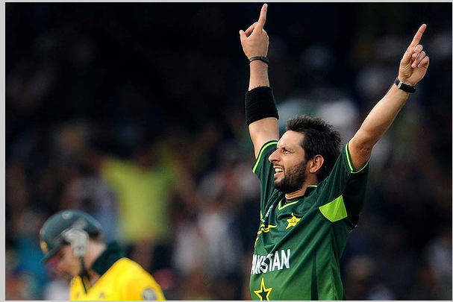

Five operations:

1. [I, rect] = imcrop(A);

imshow(I)

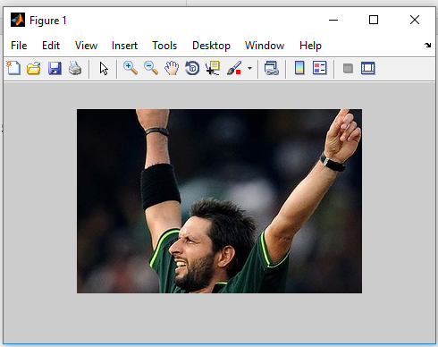

This function imcrop takes a particular portion of the complete matrix and then display it separately

In this kind of crop only rectangular matrix of the total matrix is considered for cropping

1. M=imrotate(C,20,’bicubic’,’crop’);

Imshow(M);

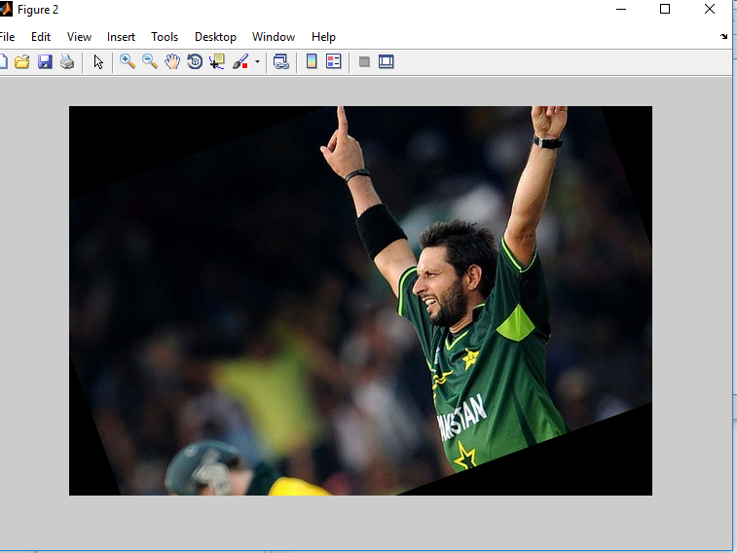

In this function imrotate command rotates the matrix at some angle and in this process some of the values will get out of the matrix these values are discarded and zeros are patched in empty places to create the matrix of same order

1. J = imnoise(C,’guassian’);

Imshow(J)

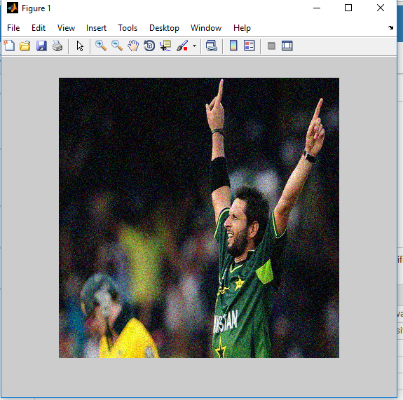

In this command imnoise guassian the white noise is added meaning that some elements of the matrix are replaced by white colour intensity element which in return created some distortion in the image

1. Z = imabsdiff(C,D)

Imshow(Z);

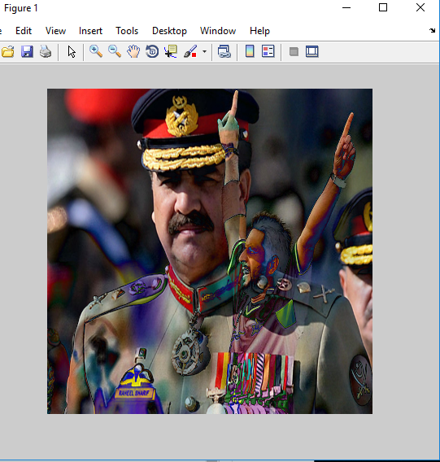

Function imabsdiff takes the absolute difference of two images in this process each element of the first matrix is subtracted from the element of the second matrix and there absolute values are considered in the result so in this process Afridi image as less dominating so after taking difference this image is just disappearing

1. M = imdivide(C,D);

imshow(M)

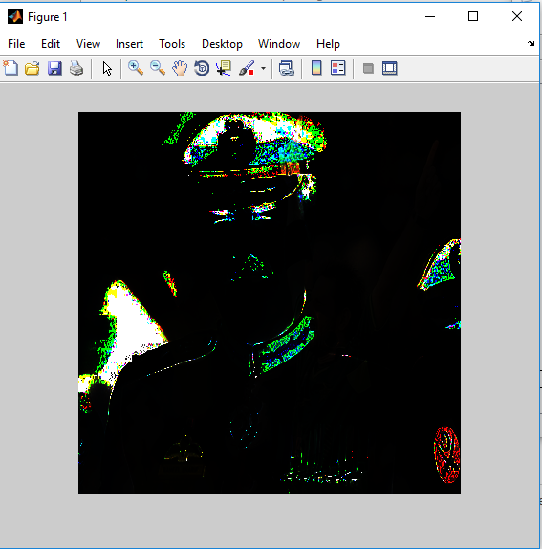

The function imdivide divides the each value of the first matrix to corresponding value of the second matrix so in this figure when these values are divided answer becomes very small in most of the areas that it corresponds to the black while small portions are colorful as well